**Exercise 1: Mocking and Stubbing**

**1.Create a mock object for the external API.**

**Code:**

package com.example.Junit_and_Mokito;

public interface ExternalApi {

    String getData();

}

**2.** **Service That Uses the API**

**Code:**

package com.example.Junit_and_Mokito;

public class MyService {

    private final ExternalApi api;

    public MyService(ExternalApi api) {

        this.api = api;

    }

    public String fetchData() {

        return api.getData();

    }

}

**3.** **Write a test case that uses the mock object.**

**Code:**

package com.example.Junit_and_Mokito;

import static org.junit.jupiter.api.Assertions.assertEquals;

import org.junit.jupiter.api.Test;

import org.mockito.Mockito;

import static org.mockito.Mockito.when;

public class MyServiceTest {

    @Test

    public void testExternalApi() {

        ExternalApi mockApi = Mockito.mock(ExternalApi.class);

        when(mockApi.getData()).thenReturn("Mock Data");

        MyService service = new MyService(mockApi);

        String result = service.fetchData();

        assertEquals("Mock Data", result);

    }

}

**Output:**

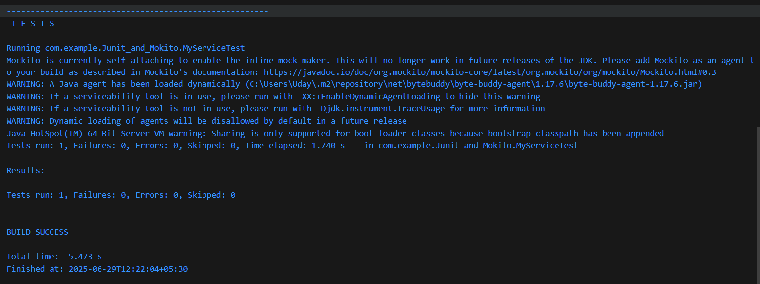

**Exercise 2: Verifying Interactions**

Step 1 and 2 are same as before.

**3. Verify the interaction**

**Code:**

import static org.mockito.Mockito.*;

import org.junit.jupiter.api.Test;

import org.mockito.Mockito;

public class MyServiceTest {

@Test

public void testVerifyInteraction() {

ExternalApi mockApi = Mockito.mock(ExternalApi.class);

MyService service = new MyService(mockApi);

service.fetchData();

verify(mockApi).getData();

}

}

**Output:**

